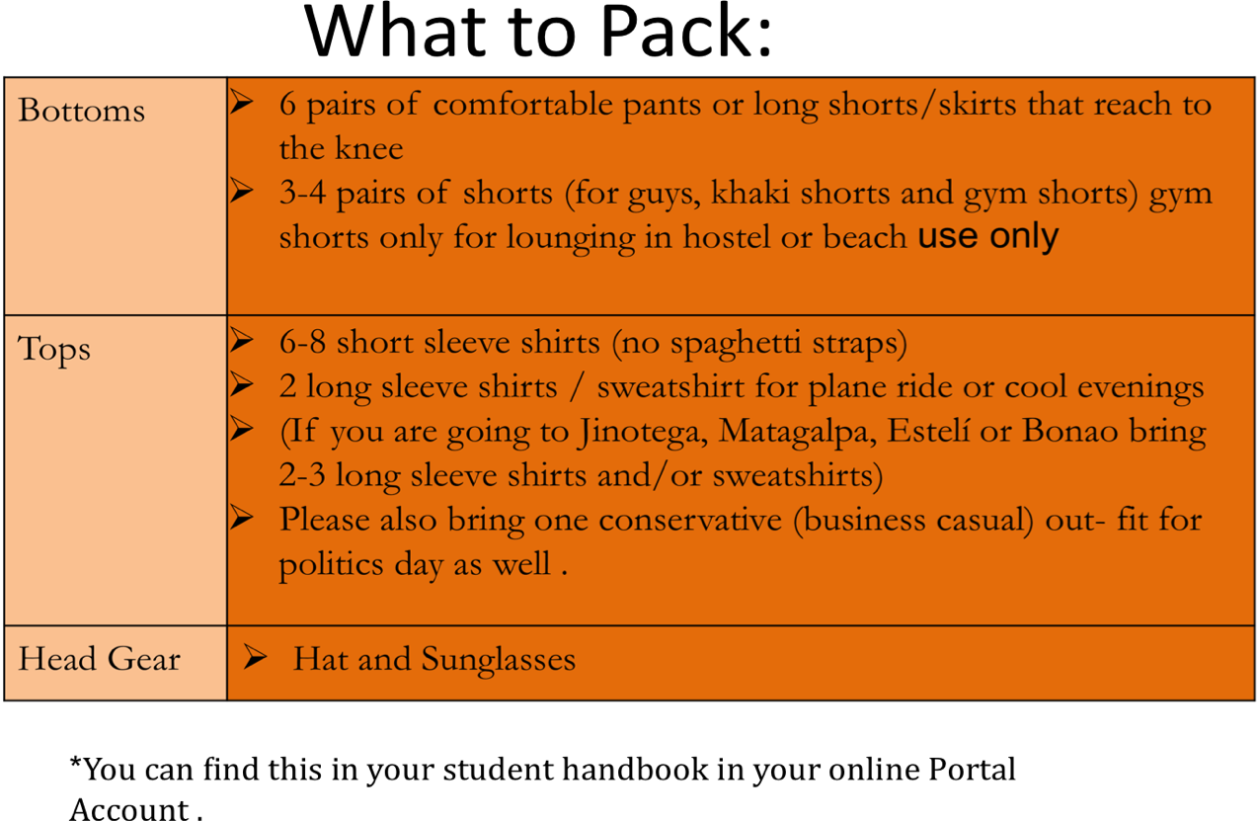
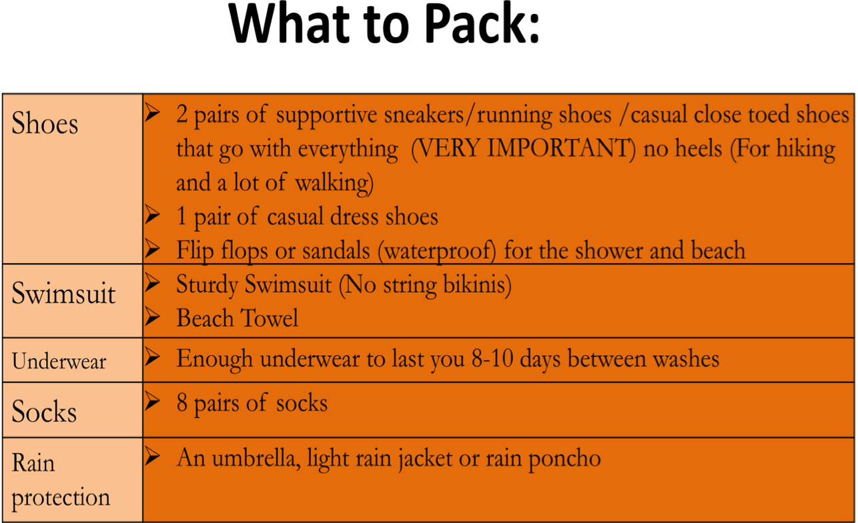
Baggage | Ø1 check luggage (must be under 50 pounds)  Ø1 small backpack to carry water, journal, sunscreen, bug spray, book, and raingear around during field trips  ØPlease be aware that not every airline has a free checked baggage policy. Please go on the airlines website and double check the baggage fee.
Other | ØMoney: $80-$200 for visa, laundry, service, souvenirs or snacks  ØMake sure cash is clean and free of tears, markings, and excessive wrinkles  Ø1 liter water bottle REQUIRED (to drink the purified water from)  Ø1 Beach Towel and 1 Face Towel  ØSunscreen! Bug Spray! B1 vitamins!  ØWrist watch  ØNica students: Uniform for the Shadowing a High School student :White shits, navy blue pants or skirt (knee length)  ØDR students: One conservative business casual outfit for politics day.  ØCord to connect camera to computer (if you want)  ØThe electrical current is 110 AZ/ 60 Hertz (identical to the US)

